EMPLOYEE MANAGEMENT SYSTEM

SYNOPSIS
Most educational institutions are doing a counselling their mentally ill students in their institutions, in that case the educational intuitions need to manage the records of counselling, like, counsellors’ details, counselling types, attendees’ details, etc. there is no application to maintain this, so we need an exclusive application to handle this. In this application we use three panels, like admin, students and staffs. Admin can register the staffs and students’ details and allot the staffs to the students based on the counselling type they needed. Then admin can add the counselling type. Admin can view the report. The staffs can login and notify the student’s availability. This application is developed

ORGANIZATION PROFILE
"Established in 2015, infoem solutions-providing unique websites, Mobile apps for android & ios. A global leader in Skills and Talent Development offers multi-disciplinary learning management and training delivery solutions to corporations, institutions, and individuals. Infoem has three main lines of business across the globe- Website and App development, Inplant Training, and Corporate Training-Placements. Infoem has a wide-range of technical experience from the people who are working in top level MNC's. We provide training in such a way that the students are equipped to work in any top level MNCs and abroad. The training solutions of us are one of a kind and are very unique and dynamic.

SYSTEM SPECIFICATION
We have a wide range of options of languages. From these options we can choose appropriate platform/ tools and languages for development of the project. Some of these are as follows: -
SOFTWARE SPECIFICATION:
Operating system : Windows 2000 or later

Front End : HTML, CSS, PHP
Back End : MySQL

HARDWARE SPECIFICATIONS
Processor : Intel Pentium or more

Ram : 128 MB or more
Cache : 512 KB
Hard disk : 16 GB hard disk recommended
SYSTEM STUDY

EXISTING SYSTEM
In the present Employee Management System of data management, some person maintains the data manually, which required a high amount of time as there are so many people work in the organization. The organization keeps the record of all the employees in the paper which is not a secure way of maintaining the data. As there is a high amount of register in which information is stored consume a lot of space in the organization while retrieving any information from that many files consume huge time and it is not an easy process.

DESCRIPTION:
An employee management system or EMS is a tool that helps improve employee satisfaction and productivity to help a company achieve their overall goals. These tools help monitor, assess and control employees' working hours and efficiently utilise human resources.
It ensures that HR efficiently manages each employee's payroll and disburses salaries on time. An EMS securely stores and manages the personal and work-related details of employees. This makes it easier for the managers to store and access relevant data when needed.
With the right EMS tool, the HR department can implement processes and help companies achieve their business objectives. By helping managers keep track of admin activities, the tool can help improve employee engagement and increase productivity. These tools also help a company with vacations and absence management and timekeeping. It can even help HR managers and organisational leaders track performance reviews of employees.

DRAWBACKS:
COLLABORATION
It may be easier to determine employees' abilities related to collaboration in team-based appraisals because team success depends on collaborative working relationships. However, as supervisors assign individual employees to teams, collaboration is an obvious expectation and may, therefore, appear to be forced upon employees. Individual appraisals that evaluate an employee's ability to collaborate with coworkers measures collaboration on an organic level, instead of the expectations associated with teamwork. When supervisors appraise individual employees' abilities to work collaboratively with others, the appraisal also includes an employee's ability to determine when or if collaboration is necessary.

FUNCTIONAL KNOWLEDGE
Team members with greater job knowledge or higher levels of functional expertise often pick up the slack for team members who lack their cohorts' experience in the field. Using team appraisals, evaluating job knowledge is difficult at best. Individual appraisals often focus specifically on an employee's ability to demonstrate proficiency in certain job-specific duties, and therefore, provide more accurate assessments of employee strengths and weaknesses.

OUTCOMES
The difference between measuring outcomes for teams vs. individuals is minimal where appraisals are concerned. The same time management skills necessary to complete assigned projects in a team-based situation are virtually the same requirements for individual accomplishments. On the other hand, when the team misses deadlines and is unable to fulfill a supervisor's expectations, team members' working relationships tend to suffer. Evaluating the ability to develop productive working relationships then becomes an additional factor upon which a supervisor has to assess team performance. Resolving time management issues in a team-oriented situation is much more challenging than addressing time management problems an individual employee may have.

COMPENSATION AND REWARDS
Many employers' compensation structures are tied to employee performance, meaning salary increases, bonuses and incentives reflect how well employees perform their job duties. Compensation rewards for team-based appraisals aren't impossible, but some team members might consider them unfair because there are likely to be inequities in the distribution of rewards for team achievements. The disadvantage of team rewards is that they cannot reasonably acknowledge individual employee contributions. Using individual appraisals in performance management to justify compensation and employee rewards is easily accomplished.

PROPOSED SYSTEM
This Employee Management System project will help the organization with the management of the information of the employees. The system will centralize the management system and will provide different options through access to data will become accessible. The system will be based on the internet so that any user can use it from any place with ease. The Employee Management System software will make a report of each employee of the organization at the end of the month so that the organization will have information about the work of each employee. This Employee Management System will not only reduce the time but as well it will make the system efficient.

DESCRIPTION
The function of human resources departments is administrative and common to all organizations. Organizations may have formalized selection, evaluation, and payroll processes. Management of "human capital" has progressed to an imperative and complex process. The HR function consists of tracking existing employee data, which traditionally includes personal histories, skills, capabilities, accomplishments, and salary. To reduce the manual workload of these administrative activities, organizations began to electronically automate many of these processes by introducing specialized human resource management systems.
HR executives rely on internal or external IT professionals to develop and maintain an integrated HRMS. Before client–server architectures evolved in the late 1980s, many HR automation processes were relegated to mainframe computers that could handle large amounts of data transactions. In consequence of the high capital investment necessary to buy or program proprietary software, these internally developed HRMS were limited to organizations that possessed a large amount of capital. The advent of client-server, application service provid er, and software as a service (SaaS) or human resource management systems enabled higher administrative control of such systems. Currently, human resource management systems tend to encompass:
- Retaining staff
- Hiring
- Onboarding & Offboarding
- Administration
- Managing payroll
- Tracking and Managing employee benefits
- HR planning
- Recruiting/Learning management
- Performance management and appraisals
- Employee self-service
- Scheduling and rota management
- Absence management
- Leave management
- Reporting and analytics
- Employee reassignment
- Grievance handling by following precedents
The payroll module automates the pay process by gathering data on employee time a nd attendance, calculating various deductions and taxes, and generating periodic pay cheques and employee tax reports. Data is generally fed from human resources and timekeeping modules to calculate automatic deposit and manual cheque writing capabilities. This module can encompass all employee-related transactions as well as integrate with existing financial management systems.
The time and attendance module gathers standardized time and work related efforts. The most advanced modules provide broad flexibility in data collection methods, labor distribution capabilities and data analysis features. Cost analysis and efficiency metrics are the primary functions.
The benefits administration module provides a system for organizations to administer and track employee participation in benefits programs. These typically encompass insurance, compensation, profit sharing, and retirement.
The HR management module is a component covering many other HR aspects from application to retirement. The system records basic demographic and address data, selection, training and development, capabilities and skills management, compensation planning records and other related activities. Leading edge systems provide the ability to "read" applications and enter relevant data to applicable database fields, notify employers and provide position management and position control. Human resource management function involves the recruitment, placement, evaluation, compensation, and development of the employees of an organization. Initially, businesses used computer-based information systems to:
- produce paychecks and payroll reports;
- maintain personnel records;
- pursue talent management.
Online recruiting has become one of the primary methods employed by HR departments to garner potential candidates for available positions within an organization. Talent management systems, or recruitment modules,^{[3]} offer an integrated hiring solution for HRMS which typically encompass:
- analyzing personnel usage within an organization;
- identifying potential applicants;
- recruiting through company-facing listings;
- recruiting through online recruiting sites or publications that market to both recruiters and applicants;
- analytics within the hiring process (time to hire, source of hire, turnover);
- compliance management to ensure job ads and candidate onboarding follows government regulations.
The significant cost incurred in maintaining an organized recruitment effort, cross-posting within and across general or industry-specific job boards and maintaining a competitive exposure of availabilities has given rise to the development of a dedicated applicant tracking system (ATS) module.
The training module provides a system for organizations to administer and track employee training and development efforts. The system, normally called a "learning management system" (LMS) if a standalone product, allows HR to track education, qualifications, and skills of the employees, as well as outlining what training courses, books, CDs, web-based learning or materials are available to develop which skills. Courses can then be offered in date specific sessions, with delegates and training resources being mapped and managed within the same system. Sophisticated LMSs allow managers to approve training, budgets, and calendars alongside performance management and appraisal metrics.^{[4]}
The employee self-service module allows employees to query HR related data and perform some HR transactions over the system. Employees may query their attendance record from the system without asking the information from HR personnel. The module also lets supervisors approve O.T. requests from their subordinates through the system without overloading the task on HR department.
Many organizations have gone beyond the traditional functions and developed human resource management information systems, which support recruitment, selectio n, hiring, job placement, performance appraisals, employee benefit analysis, health, safety, and security, while others integrate an outsourced applicant tracking system that encompasses a subset of the above.
The analytics module enables organizations to extend the value of an HRMS implementation by extracting HR related data for use with other business intelligence platforms. For example, organizations combine HR metrics with other business data to identify trends and anomalies in headcount in order to better predict the impact of employee turnover on future output.
There are now many types of HRMS or HRIS, some of which are typically local-machine-based software packages; the other main type is an online cloud-based system that can be accessed via a web browser.
The staff training module enables organizations the ability to enter, track and manage employee and staff training. Each type of activity can be recorded together with the additional data. The performance of each employee or staff member is then stored and can be accessed via the Analytics module.
Employee reassign module is a recent additional functionality of HRMS. This module has the functions of transfer, promotion, pay revision, re-designation, deputation, confirmation, pay mode change and letter form.

FEATURES:
Time & Attendance Management
Keeping track of employee time and attendance manually can be time-consuming. Time management is also a big part of the employee management system. Any organization can not turn away their employees without Time management skills So, the digital workforce management system ensures accurate reporting that helps calculate productive hours for error-free payroll.

Absence & Leave Management
Best Employee Management systems allow employees to get all the information about leave policies so they can plan their leave accordingly. Also, it helps managers notify automatically about their requests for approval or denial.

Employee database management
Companies store detailed information about employees for future usage. Therefore, employee management system software records accurate data with specific security measures to keep employee information safe.

Employee self-service
Effective Employee Management Systems allow employees to maintain HR-related matters. It can improve productivity and efficiency by letting employees set their availability at work and helps them reduce the risk of entry errors.

SYSTEM DESIGN AND DEVELOPMENT

INTRODUCTION
Analysis collects a great deal of unstructured data through interviews, questionnaires, on-site observations, and procedural manuals and like. It is required to organize and convert the data through system flowcharts, data flow diagrams, structured English, decision tables and the like which support future development of the system.
The Data flow diagrams and various processing logic techniques show how, where, and when data are used or changed in an information system, but these techniques do not show the definition, structure and relationships within the data.
It is a way to focus on functions rather than the physical implementation. This is analogous to the architect’s blueprint as a starting point for system design. The design is a solution, a “how to” approach, compared to analysis, a “what is” orientation.
System design is a highly creative process. This system design process is also referred as data modeling. The most common formatted used the E-R notation explains the characteristics and structure of data independent of how the data may be stored in computer memories.
The process of system design can be divided into three stages. They are:
Structure design (already discussed)
Database design
Interface design

As we know that system design is a solution to “How to approach to the creation of new system”. It provides the understudying and procedural details necessary for implementing the system. The steps involved during system design were as follow: -

FILE DESIGN
The current physical system was thoroughly reviewed from point of view how the data flow, what are file contents, its volumes and frequency etc.
After this input, output specifications security & control specification were prepared. It was also decided that how physical information will flow through the system and a physical design walkthrough.

INPUT DESIGN
.Input should be as simple as possible. It is design to reduce possibility of incorrect data being enter and the need of system user are considered with this view of mind several human factor is evaluated.

OUTPUT DESIGN
The format of outputs is designed in such a way that it is simple to read and interpret In the present output we have clearly labeled title it contains date and time and all the fields are clearly mentioned (labeled).

CODE DESIGN
There are a number of attributes of software that can serve as requirements. It is important that required attributes by specified so that their achievement can be objectively verified. The following items provide a partial list of examples. These are also known as non-functional requirements or quality attributes. These are characteristics the system must possess, but that pervade (or cross-cut) the design. These requirements have to be testable just like the functional requirements.

DATABASE DESIGN
The general theme behind a database is to handle information as an integrated whole. A database is a collection of interrelated data stored with minimum redundancy to serve many users quickly and efficiently. The general objective is to make information access easy quick and flexible for user.

SYSTEM DEVELOPMENT:
A systems development life cycle is composed of a number of clearly defined and distinct work phases which are used by systems engineers and systems developers to plan for, design, build, test, and deliver information systems. Like anything that is manufactured on an assembly line, an SDLC aims to produce high-quality systems that meet or exceed customer expectations, based on customer requirements, by delivering systems which move through each clearly defined phase, within scheduled time frames and cost estimates.^{[3]} Computer systems are complex and often (especially with the recent rise of service-oriented architecture) link multiple traditional systems potentially supplied by different software vendors. To manage this level of complexity, a number of SDLC models or methodologies have been created, such as waterfall, spiral, Agile software development, rapid prototyping, incremental, and synchronize and stabilize.

DESCRIPTION OF MODULES

- Job data changes
- Salary distribution changes
- Additional pay
- Effort certification
- Leaves
- Terminations
- Form Gs
- Instructional hiring
U-M units and central office staff administer salary plans and process annual merit pay. They also process annual contractual rate increases and personnel transactions, including changes to personal demographic, appointment, and funding information.
Other activities supported by the HR module include:
- Managing employee relations, which deals with filing and managing grievance and disciplinary actions.
- Managing competencies, which is used by Michigan Medicine (MM) to perform required tracking and reporting on skills and qualifications of MM staff.
PROBLEM DEFINITION

Lack of Immediate retrivals : The information is very difficult to retrieve and to find particular information like- E.g. - To find out about the patient’s history, the user has to go through various registers. This results in in convenienceand wastage of time.

Technical system : The information generated by various transactions takes time and efforts to be stored at right place. Various changes to information like patient details or immunization details of child are difficult to make as paper work is involved.
SYSTEM DESIGN AND DEVELOPMENT

CONCLUSION
The Hospital Management System is designed for any hospital to replace their existing manual paper based system. The new system is to control the information of patients. Room availability, staff and operating room schedules and patient invoices. These services are to be provided in an efficient, cost effective manner, with the goal of reducing the time and resources currently required for such tasks .

BIBLIOGRAPHY

Websites
- http://www.google.com
- http://www.microsoft.com
- http://www.codeproject.com
- http://www.msdn.com.
- http://www.vb123.com
- http://www.phpPot.com
- http://www.sqltuner.com

Books
- Mastering PHP 6 (Paperback)
- PHP Basic Black Book (Paperback)
- SQL Bible, 2nd Edition (Paperback)
- Database Development in PHP

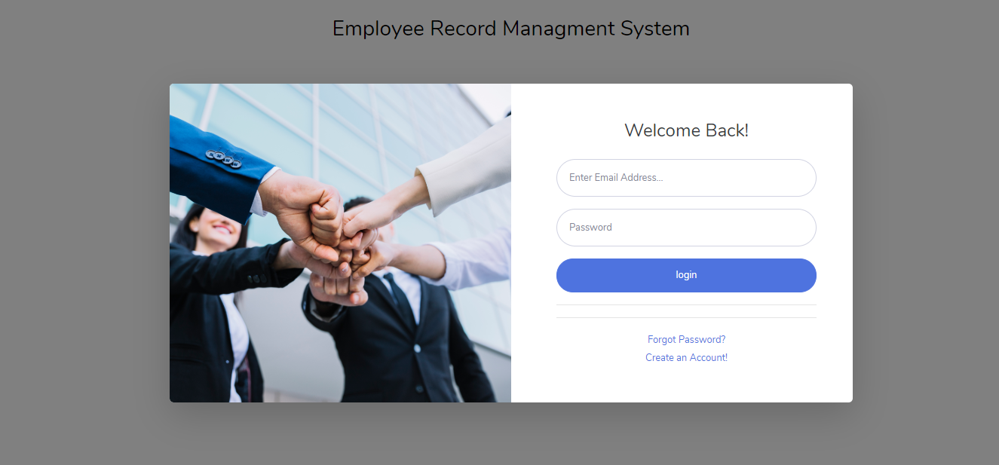

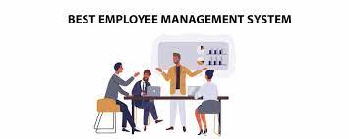

REGISTERATION :

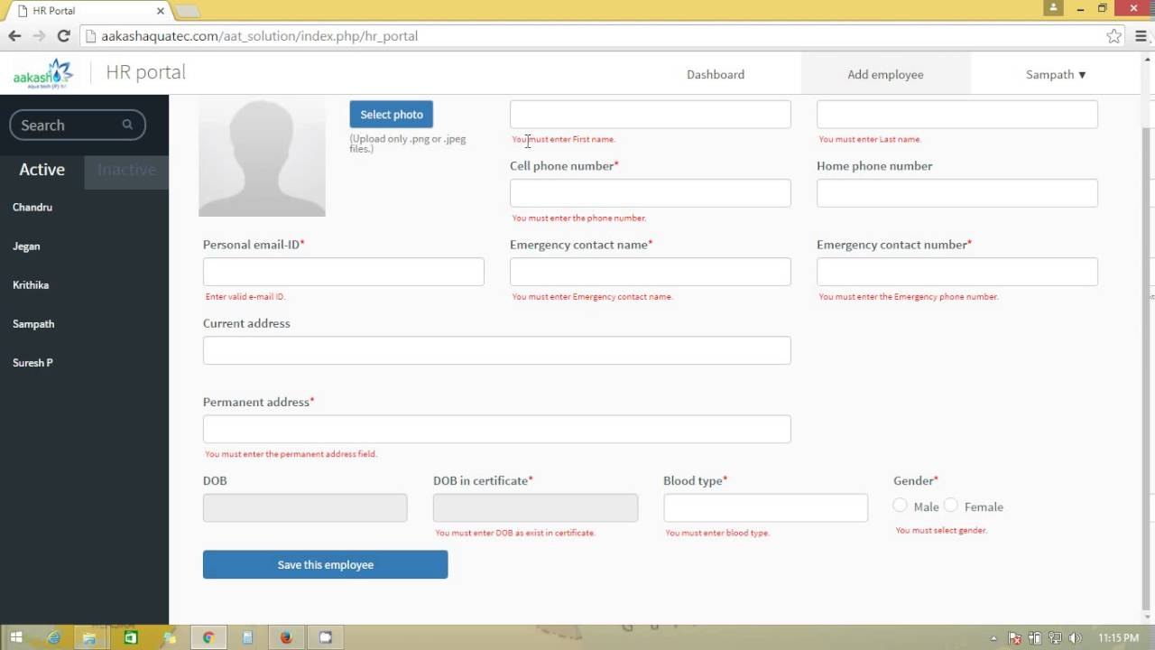

EMPLOYEE DETAILS :

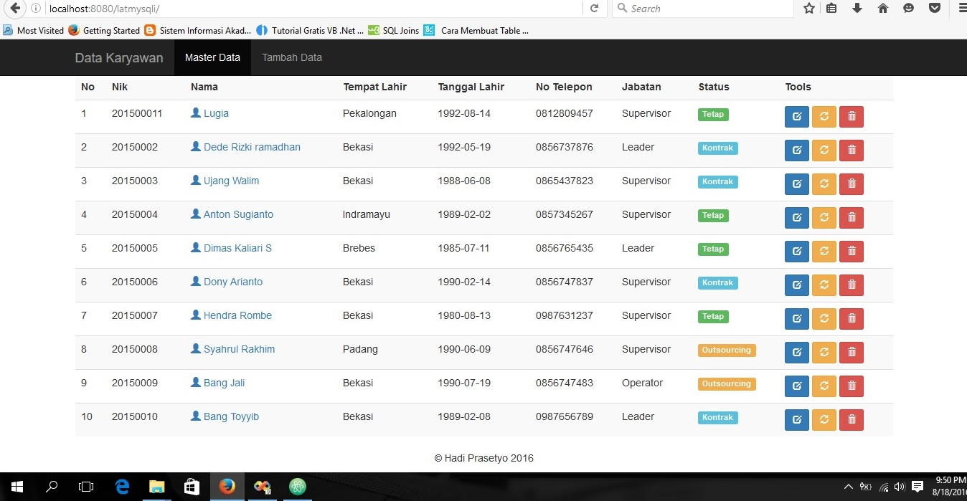

EMPLOYEE LEAVES :
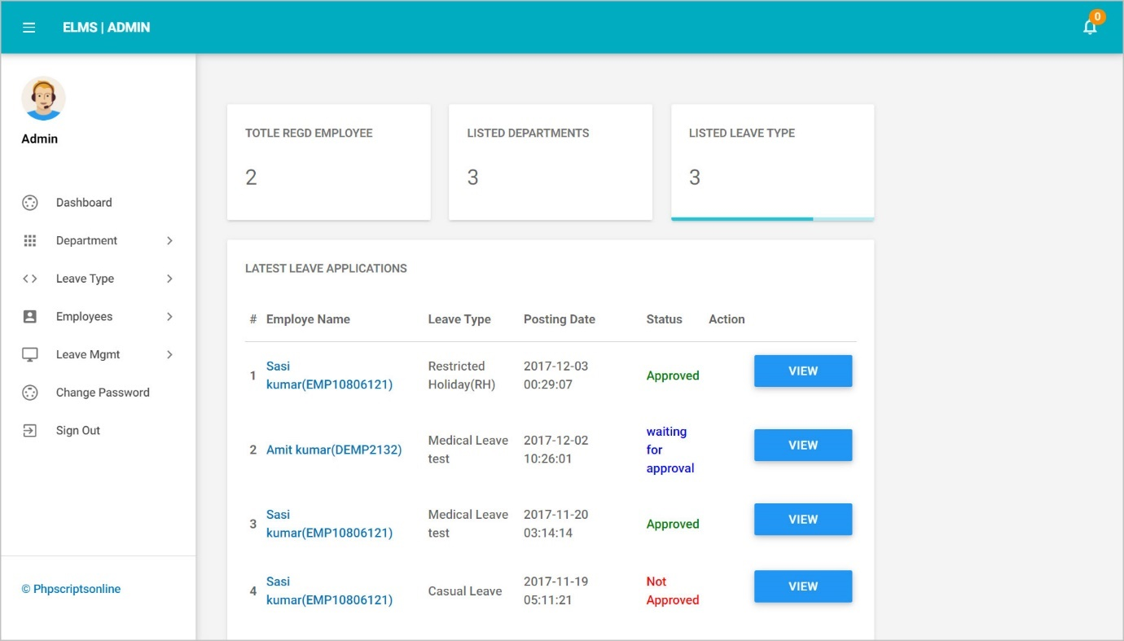
//connect to db
<?php
$con=mysqli_connect("Localhost", "root", "", "ermsdb");
if(mysqli_connect_errno()){
echo "Connection Fail".mysqli_connect_error();
}

?>

//index page

<body id="page-top">
<!-- Page Wrapper -->
<div id="wrapper" >
<!-- Content Wrapper -->
<div id="content-wrapper" class="d-flex flex-column">
<!-- Main Content -->
<div id="content">
<!-- Begin Page Content -->
<div class="container-fluid">
<!-- Page Heading -->
<div class="d-sm-flex align-items-center justify-content-between mb-4" style="margin-top: 2%">
<h1 class="h3 mb-0 text-gray-800">Employee Record Management System</h1>
</div>

<div class="row">

<!-- Earnings (Monthly) Card Example -->

<div class="col-xl-4 col-md-6 mb-4">
<div class="card border-left-primary shadow h-100 py-2">
<div class="card-body">
<div class="row no-gutters align-items-center">
<div class="col mr-2"> <a href="loginerms.php">
<div class="text-xs font-weight-bold text-primary text-uppercase mb-1">User Signin</div>
</a>
</div>
<div class="col-auto">
<i class="fas fa-user fa-2x text-gray-300"></i>
</div>
</div>
</div>
</div>
</div>

<!-- Earnings (Monthly) Card Example -->
<div class="col-xl-4 col-md-6 mb-4">
<div class="card border-left-success shadow h-100 py-2">
<div class="card-body">
<div class="row no-gutters align-items-center">
<div class="col mr-2">
<a href="registererms.php">
<div class="text-xs font-weight-bold text-success text-uppercase mb-1">User Signup</div>
</a>
</div>
<div class="col-auto">
<i class="fas fa-user fa-2x text-gray-300"></i>
</div>
</div>
</div>
</div>
</div>

<!-- Earnings (Monthly) Card Example -->
<div class="col-xl-4 col-md-6 mb-4">
<div class="card border-left-info shadow h-100 py-2">
<div class="card-body">
<div class="row no-gutters align-items-center">
<div class="col mr-2">
<a href="admin/">
<div class="text-xs font-weight-bold text-info text-uppercase mb-1">Admin Login</div>
</a>
</div>
<div class="col-auto">
<i class="fas fa-user fa-2x text-gray-300"></i>
</div>
</div>
</div>
</div>
</div>

<!-- Pending Requests Card Example -->

</div>

</div>
<!-- /.container-fluid -->

</div>
<!-- End of Main Content -->

<!-- Footer -->
<?php include_once('includes/footer.php');?>
<!-- End of Footer -->

</div>
<!-- End of Content Wrapper -->

</div>
<!-- End of Page Wrapper -->

<!-- Scroll to Top Button-->
<a class="scroll-to-top rounded" href="#page-top">
<i class="fas fa-angle-up"></i>
</a>

<!-- Logout Modal-->
<div class="modal fade" id="logoutModal" tabindex="-1" role="dialog" aria-labelledby="exampleModalLabel" aria-hidden="true">
<div class="modal-dialog" role="document">
<div class="modal-content">
<div class="modal-header">
<h5 class="modal-title" id="exampleModalLabel">Ready to Leave?</h5>
<button class="close" type="button" data-dismiss="modal" aria-label="Close">
<span aria-hidden="true">×</span>
</button>
</div>
<div class="modal-body">Select "Logout" below if you are ready to end your current session.</div>
<div class="modal-footer">
<button class="btn btn-secondary" type="button" data-dismiss="modal">Cancel</button>
<a class="btn btn-primary" href="login.html">Logout</a>
</div>
</div>
</div>
</div>

<!-- Bootstrap core JavaScript-->
<script src="vendor/jquery/jquery.min.js"></script>
<script src="vendor/bootstrap/js/bootstrap.bundle.min.js"></script>

<!-- Core plugin JavaScript-->
<script src="vendor/jquery-easing/jquery.easing.min.js"></script>

<!-- Custom scripts for all pages-->
<script src="js/sb-admin-2.min.js"></script>

</body>

// login
<?php
session_start();
error_reporting(0);
include('includes/dbconnection.php');

if(isset($_POST['login']))
{
$Email=$_POST['Email'];
$Password=$_POST['Password'];
$query=mysqli_query($con,"select ID from employeedetail where EmpEmail='$Email' && EmpPassword='$Password' ");
$ret=mysqli_fetch_array($query);
if($ret>0){
$_SESSION['uid']=$ret['ID'];
header('location:welcome.php');
}
else{
$msg="Invalid Details.";
}
}
?>

<!DOCTYPE html>
<html lang="en">

<head>

<meta charset="utf-8">
<meta http-equiv="X-UA-Compatible" content="IE=edge">
<meta name="viewport" content="Employee Record management System in php and mysql">
<meta name="description" content="Employee Record management System in php and mysql">
<meta name="author" content="Sarita Pandey">

<title>ERMS Employee Login</title>

<!-- Custom fonts for this template-->
<link href="vendor/fontawesome-free/css/all.min.css" rel="stylesheet" type="text/css">
<link href="https://fonts.googleapis.com/css?family=Nunito:200,200i,300,300i,400,400i,600,600i,700,700i,800,800i,900,900i" rel="stylesheet">

<!-- Custom styles for this template-->
<link href="css/sb-admin-2.min.css" rel="stylesheet">

</head>

<body class="bg-gradient-primary">

<div class="container">
<h3 align="center" style="color: black; padding-top: 2%">Employee Record Managment System</h3>

<!-- Outer Row -->
<div class="row justify-content-center">

<div class="col-xl-10 col-lg-12 col-md-9">

<div class="card o-hidden border-0 shadow-lg my-5">
<div class="card-body p-0">

<!-- Nested Row within Card Body -->
<div class="row">
<div class="col-lg-6 d-none d-lg-block bg-login-image"></div>
<div class="col-lg-6">
<div class="p-5">
<div class="text-center">
<h1 class="h4 text-gray-900 mb-4">Welcome Back!</h1>
</div>
<p style="font-size:16px; color:red" align="center"> <?php if($msg){
echo $msg;
} ?> </p>
<form class="user" method="post" action="">
<div class="form-group">
<input type="email" class="form-control form-control-user" id="Email" name="Email" aria-describedby="emailHelp" placeholder="Enter Email Address..." required="true">
</div>
<div class="form-group">
<input type="password" class="form-control form-control-user" id="Password" name="Password" placeholder="Password" required="true">
</div>

<p> <input type="submit" class="btn btn-primary btn-user btn-block" name="login" value="login"></p>

<hr>

</form>
<hr>
<div class="text-center">
<a class="small" href="forgetpassword.php">Forgot Password?</a>
</div>
<div class="text-center">
<a class="small" href="registererms.php">Create an Account!</a>
</div>
</div>
</div>
</div>
</div>
</div>

</div>

</div>

</div>

<!-- Bootstrap core JavaScript-->
<script src="vendor/jquery/jquery.min.js"></script>
<script src="vendor/bootstrap/js/bootstrap.bundle.min.js"></script>

<!-- Core plugin JavaScript-->
<script src="vendor/jquery-easing/jquery.easing.min.js"></script>

<!-- Custom scripts for all pages-->
<script src="js/sb-admin-2.min.js"></script>

</body>

</html>

//admin
<?php
session_start();
include('includes/dbconnection.php');

if(isset($_POST['login']))
{
$uname=$_POST['username'];
$Password=$_POST['Password'];
$query=mysqli_query($con,"select ID from tbladmin where AdminuserName='$uname' && Password='$Password' ");
$ret=mysqli_fetch_array($query);
if($ret>0){
$_SESSION['aid']=$ret['ID'];
header('location:welcome.php');
}
else{
echo "Invalid Details";
}
}
?>

<!DOCTYPE html>
<html lang="en">

<head>

<meta charset="utf-8">
<meta http-equiv="X-UA-Compatible" content="IE=edge">
<meta name="viewport" content="Employee Record management System in php and mysql">
<meta name="description" content="Employee Record management System in php and mysql">
<meta name="author" content="Sarita Pandey">

<title>ERMS Admin Login</title>

<!-- Custom fonts for this template-->
<link href="../vendor/fontawesome-free/css/all.min.css" rel="stylesheet" type="text/css">
<link href="https://fonts.googleapis.com/css?family=Nunito:200,200i,300,300i,400,400i,600,600i,700,700i,800,800i,900,900i" rel="stylesheet">

<!-- Custom styles for this template-->
<link href="../css/sb-admin-2.min.css" rel="stylesheet">

</head>

<body class="bg-gradient-primary">

<div class="container">
<h3 align="center" style="color: black; padding-top: 2%">Employee Record Managment System</h3>

<!-- Outer Row -->
<div class="row justify-content-center">

<div class="col-xl-10 col-lg-12 col-md-9">

<div class="card o-hidden border-0 shadow-lg my-5">
<div class="card-body p-0">
<!-- Nested Row within Card Body -->
<div class="row">
<div class="col-lg-6 d-none d-lg-block bg-login-image"></div>
<div class="col-lg-6">
<div class="p-5">
<div class="text-center">
<h1 class="h4 text-gray-900 mb-4">Admin login!</h1>
</div>
<form class="user" method="post" action="">
<div class="form-group">
<input type="test" class="form-control form-control-user" id="username" name="username" aria-describedby="emailHelp" required="true" placeholder="Enter username ...">
</div>
<div class="form-group">
<input type="password" class="form-control form-control-user" id="Password" name="Password" placeholder="Password" required="true">
</div>

<p> <input type="submit" class="btn btn-primary btn-user btn-block" name="login" value="login"></p>

<hr>

</form>
<hr>

</div>
</div>
</div>
</div>
</div>

</div>

</div>

</div>

<!-- Bootstrap core JavaScript-->
<script src="../vendor/jquery/jquery.min.js"></script>
<script src="../vendor/bootstrap/js/bootstrap.bundle.min.js"></script>

<!-- Core plugin JavaScript-->
<script src="../vendor/jquery-easing/jquery.easing.min.js"></script>

<!-- Custom scripts for all pages-->
<script src="../js/sb-admin-2.min.js"></script>

</body>

</html>

// Register
<?php
include('includes/dbconnection.php');
error_reporting(0);
if(isset($_POST['submit']))
{
$FName=$_POST['FirstName'];
$LName=$_POST['LastName'];
$empcode=$_POST['empcode'];
$Email=$_POST['Email'];
$Password=$_POST['Password'];
//$RPassword=$_POST['RepeatPassword'];
$ret=mysqli_query($con, "select EmpEmail from employeedetail where EmpEmail='$Email'");
$result=mysqli_fetch_array($ret);
if($result>0){
$msg="This email already associated with another account";
}
else{
$query=mysqli_query($con, "insert into employeedetail(EmpFname, EmpLName, EmpCode, EmpEmail, EmpPassword) value('$FName', '$LName', '$empcode', '$Email', '$Password' )");
if ($query) {
$msg="You have successfully registered";
}
else
{
$msg="Something Went Wrong. Please try again";
}

}
}
?>

<!DOCTYPE html>
<html lang="en">

<head>

<meta charset="utf-8">
<meta http-equiv="X-UA-Compatible" content="IE=edge">
<meta name="viewport" content="width=device-width, initial-scale=1, shrink-to-fit=no">
<meta name="description" content="">
<meta name="author" content="">

<title>Employee Record Managment System</title>

<!-- Custom fonts for this template-->
<link href="vendor/fontawesome-free/css/all.min.css" rel="stylesheet" type="text/css">
<link href="https://fonts.googleapis.com/css?family=Nunito:200,200i,300,300i,400,400i,600,600i,700,700i,800,800i,900,900i" rel="stylesheet">

<!-- Custom styles for this template-->
<link href="css/sb-admin-2.min.css" rel="stylesheet">
<script type="text/javascript">
function checkpass()
{
if(document.register.Password.value!=document.register.RepeatPassword.value)
{
alert('New Password and Confirm Password field does not match');
document.register.RepeatPassword();
return false;
}
return true;
}

</script>
</head>

<body class="bg-gradient-primary">

<div class="container">
<h3 align="center" style="color: black; padding-top: 1%">Employee Record Managment System</h3>

<div class="card o-hidden border-0 shadow-lg my-5">
<div class="card-body p-0">
<!-- Nested Row within Card Body -->
<div class="row">
<div class="col-lg-5 d-none d-lg-block bg-register-image"></div>
<div class="col-lg-7">
<div class="p-5">
<div class="text-center">
<h1 class="h4 text-gray-900 mb-4">Create an Account!</h1>
</div>
<p style="font-size:16px; color:red" align="center"> <?php if($msg){
echo $msg;
} ?> </p>
<form class="user" name="register" method="post" onsubmit="return checkpass();">
<div class="form-group row">
<div class="col-sm-6 mb-3 mb-sm-0">
<input type="text" class="form-control form-control-user" id="FirstName" name="FirstName" placeholder="First Name" pattern="[A-Za-z]+" required="true">
</div>
<div class="col-sm-6">
<input type="text" class="form-control form-control-user" id="LastName" name="LastName" placeholder="Last Name" pattern="[A-Za-z]+" required="true">
</div>
</div>
<div class="form-group">
<input type="text" class="form-control form-control-user" id="empcode" name="empcode" placeholder="Enter your Employee Code" pattern="[0-9]+" required="true">
</div>
<div class="form-group">
<input type="email" class="form-control form-control-user" id="Email" name="Email" placeholder="Email Address" required="true">
</div>
<div class="form-group row">
<div class="col-sm-6 mb-3 mb-sm-0">
<input type="password" class="form-control form-control-user" id="Password" name="Password" placeholder="Password" required="true">
</div>
<div class="col-sm-6">
<input type="password" class="form-control form-control-user" id="RepeatPassword" name="RepeatPassword" placeholder="Repeat Password" required="true">
</div>

</div>

<input type="submit" name="submit" value="Register Account" class="btn btn-primary btn-user btn-block">

</form>
<hr>

<div class="text-center">
<a class="small" href="loginerms.php">Already have an account? Login!</a>
</div>
</div>
</div>
</div>
</div>
</div>

</div>

<!-- Bootstrap core JavaScript-->
<script src="vendor/jquery/jquery.min.js"></script>
<script src="vendor/bootstrap/js/bootstrap.bundle.min.js"></script>

<!-- Core plugin JavaScript-->
<script src="vendor/jquery-easing/jquery.easing.min.js"></script>

<!-- Custom scripts for all pages-->
<script src="js/sb-admin-2.min.js"></script>

</body>

</html>

//Logout

<?php
session_start();
session_unset();
session_destroy();
header('location:loginerms.php');

?>
DATAFLOW DIAGRAM:

USE CASE DIAGRAM:

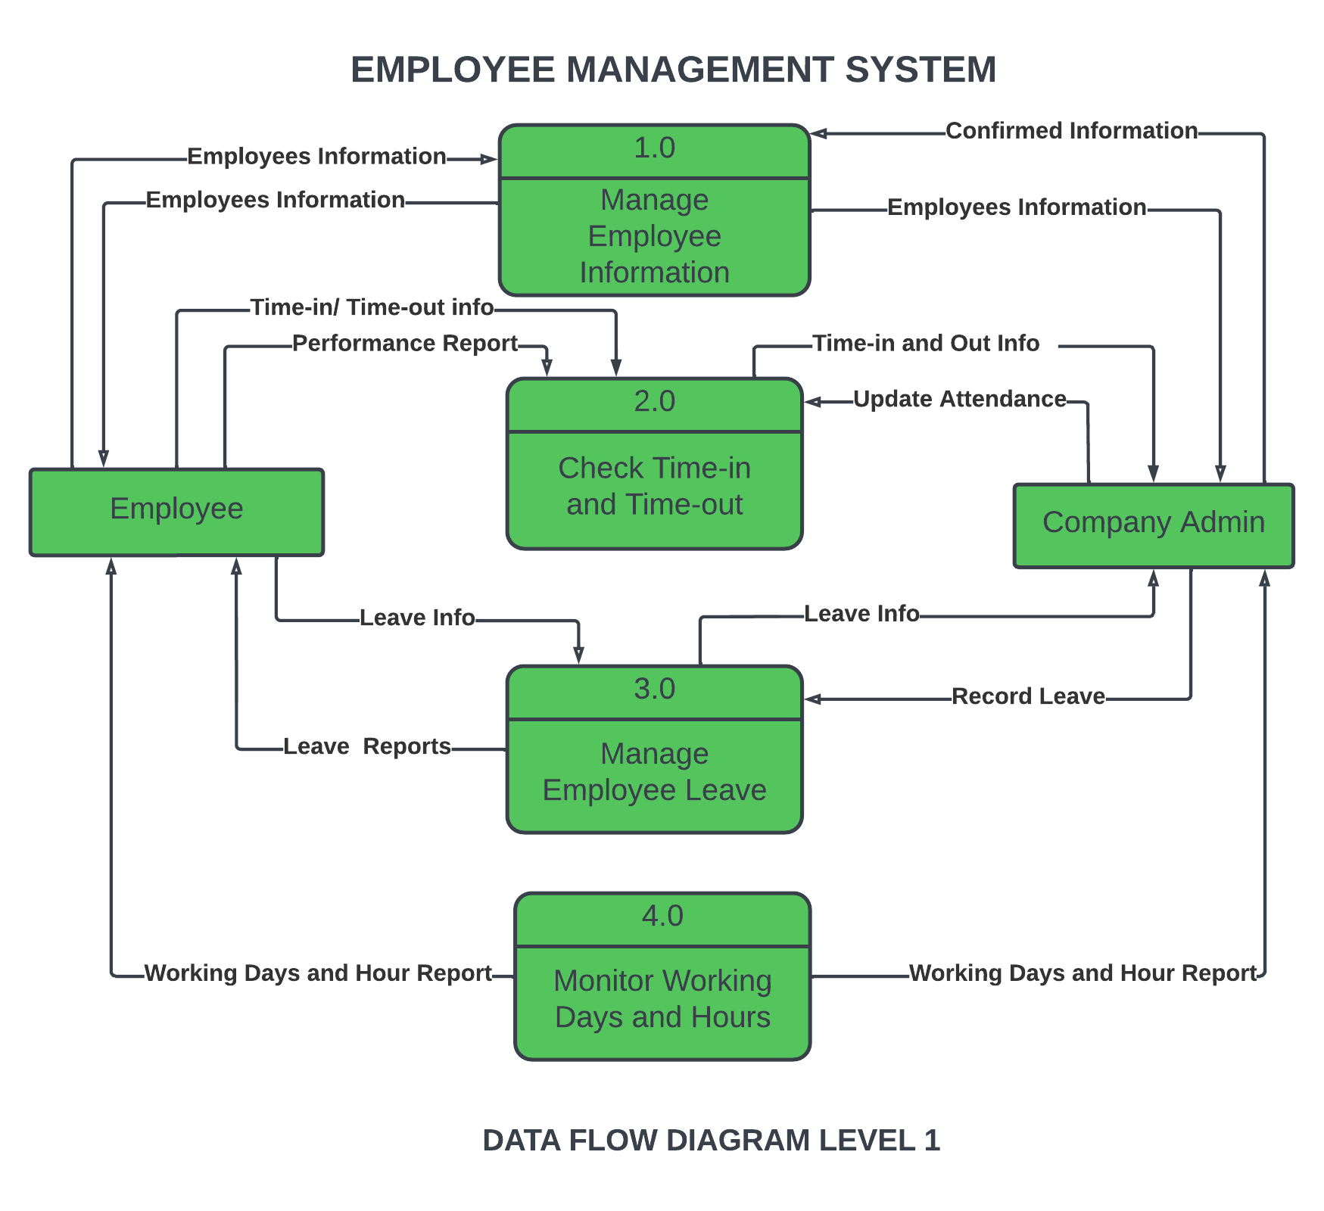
CLASS DIAGRAM:
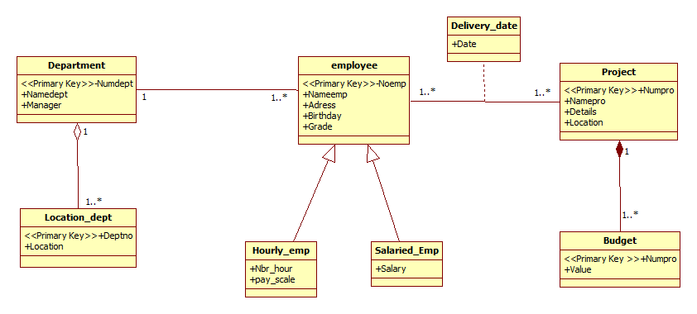

SEQUENCE DIAGRAM:

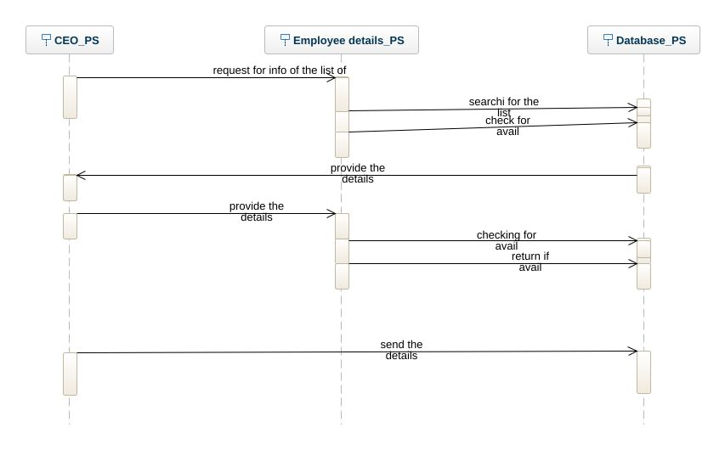

ACTIVITY DIAGRAM:
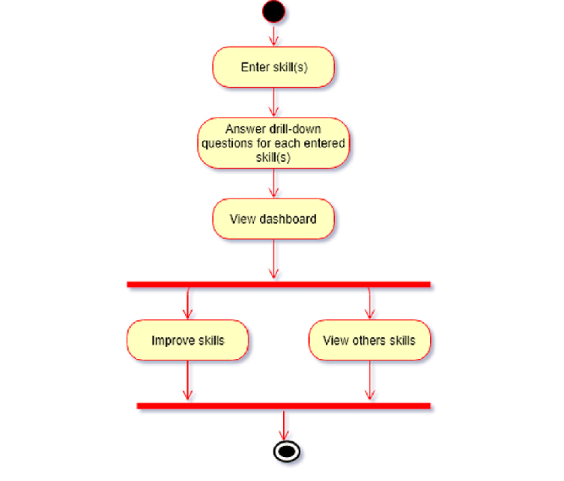
ER DIAGRAM:

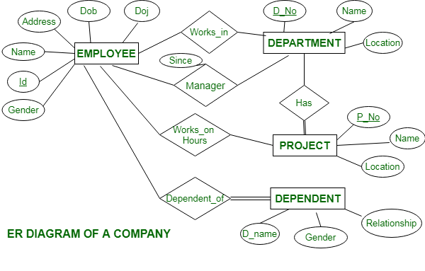

TABLE STRUCTURE

